Blueprints of Machined Parts

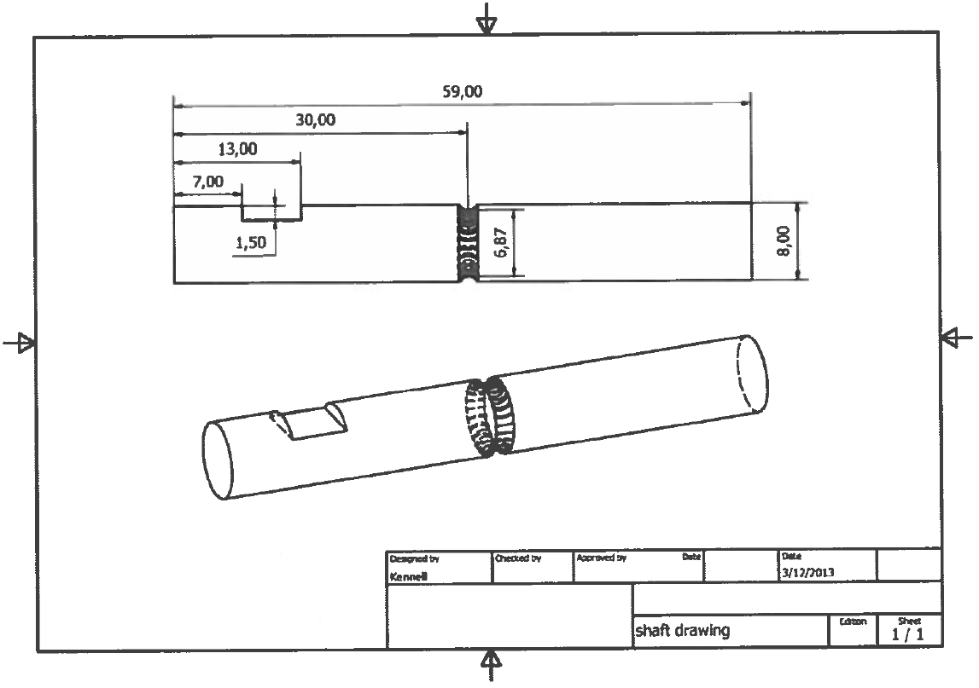

Blueprints of Machined Parts

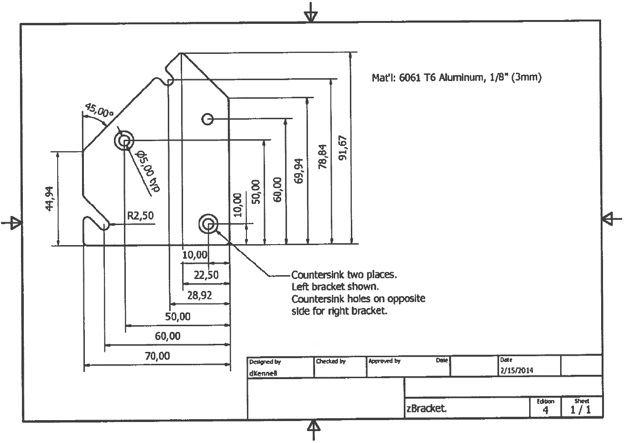

Blueprints of Machined Parts

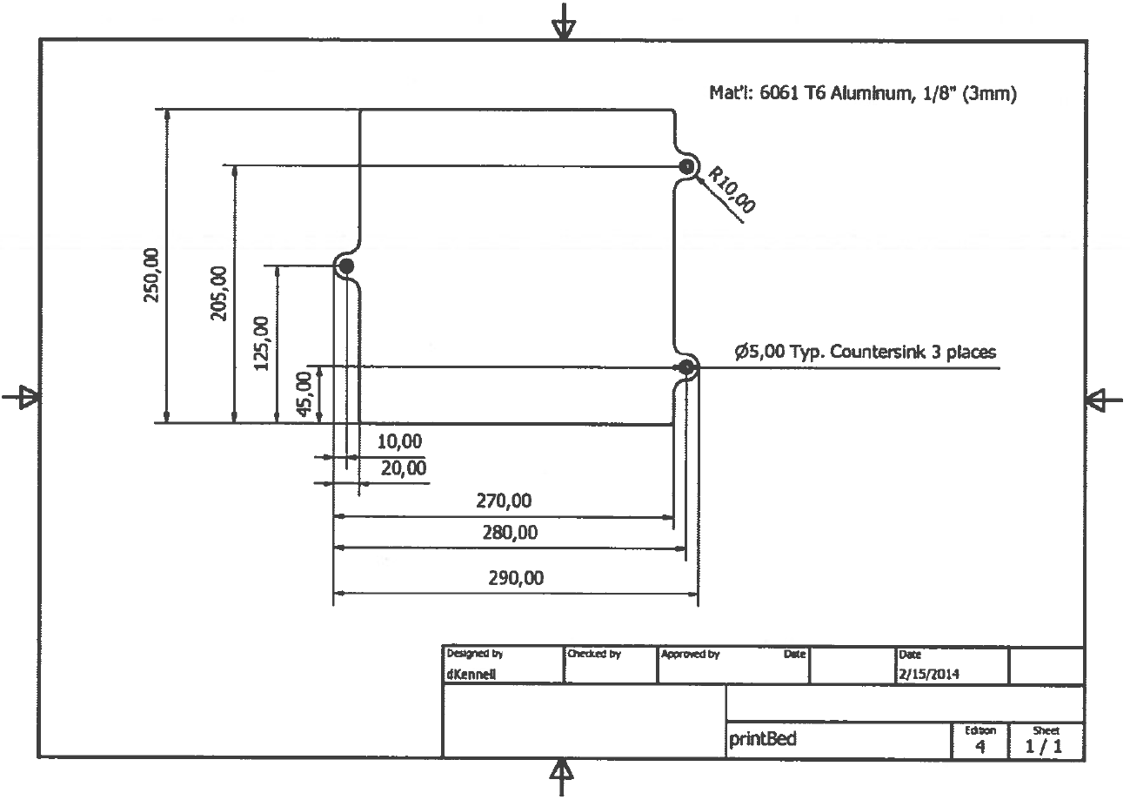

Blueprints of Machined Parts

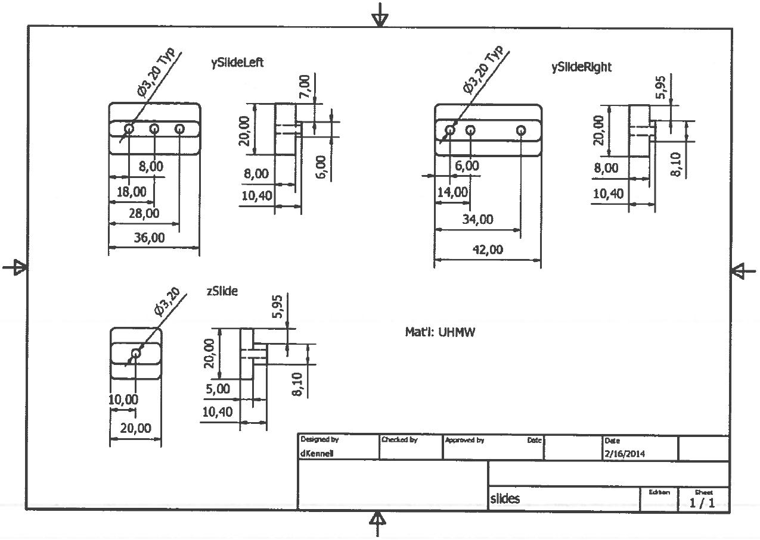

Blueprints of Machined Parts

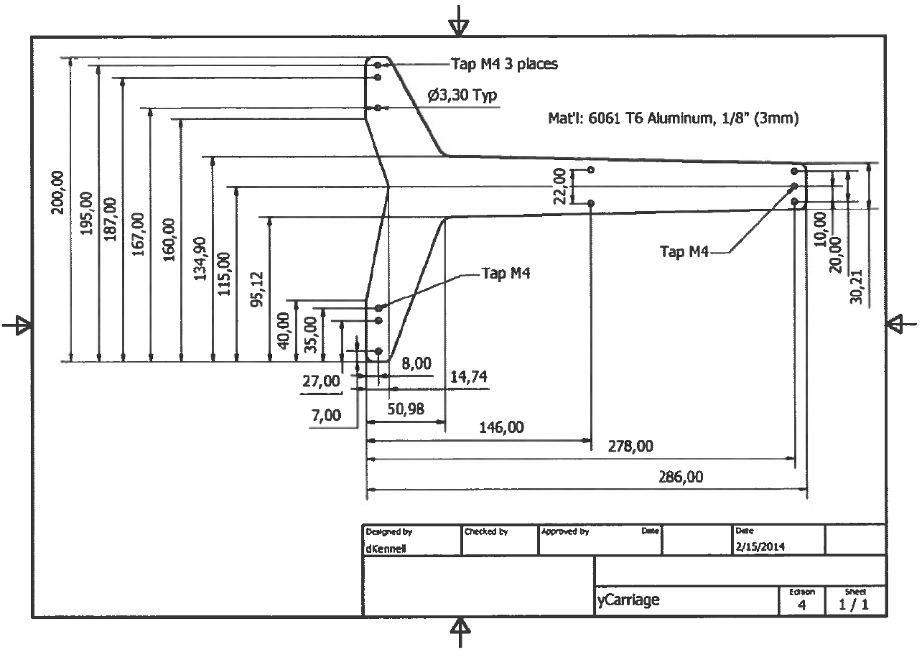

**Files on the USB Drive**

1. 3D Literacy Essentials
2. Master flexMendel 3D Printed Parts
3. flexMendel firmware file
4. PDF drawings
5. S1ic3r files
6. 3DP Inventory Check List
7. Concept to Reality Process – Short
8. flexMendel BOM Calculator
9. Plastic Part Cost Calculator
10. Printed Part Cost Information

flexMendel Part Identification Key

**Custom Aluminum Parts:**

Bed Plate

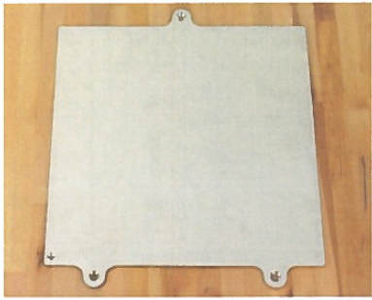

Electronics Tray

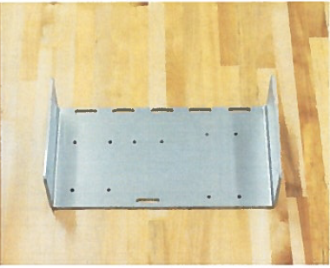

**Custom Aluminum Parts:**

Extruder Plate

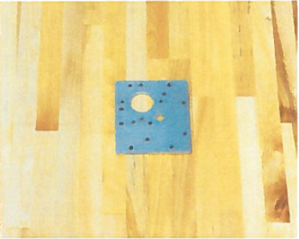

Hotend Plate

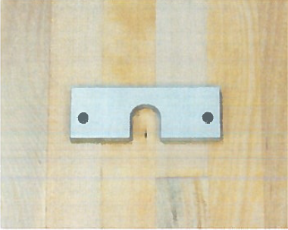

**Custom Aluminum Parts:**

X Carriage Plates (Motor and Idler)

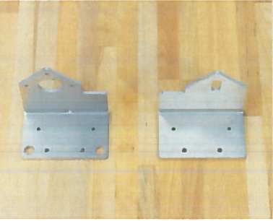

Y Carriage

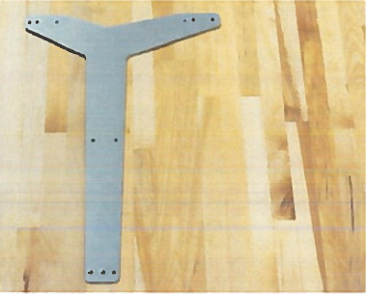

**Custom Aluminum Parts:**

Y Idler Bracket

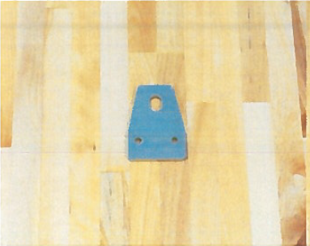

Y Motor Bracket

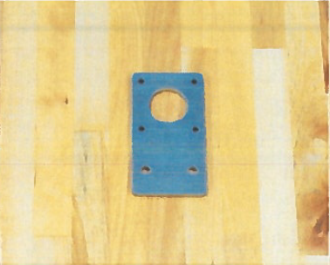

|  |  |
| --- | --- |
| Z Brackets |  |

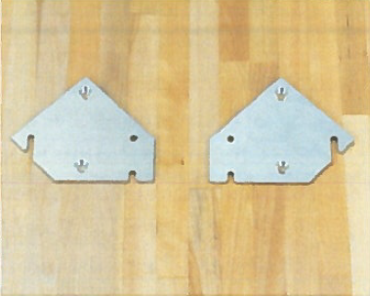

Z Motor Brackets (Left and Right)



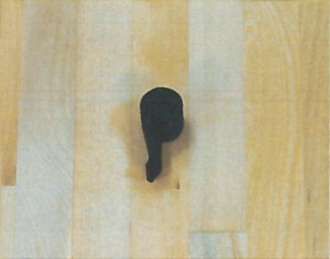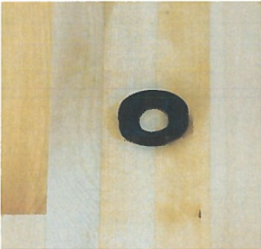3D Printed Parts: Extruder

|  |  |
| --- | --- |
| Bearing Circle | Cam |

|  |  |
| --- | --- |
| Pinch Lever and Extruder Front | Gearbox6 |

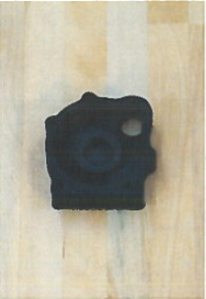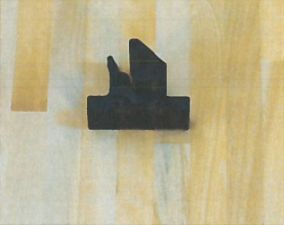

|  |  |
| --- | --- |
| X Belt Bracket and Clamp | X Carriage V2 |

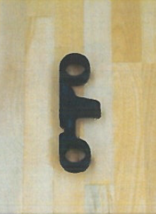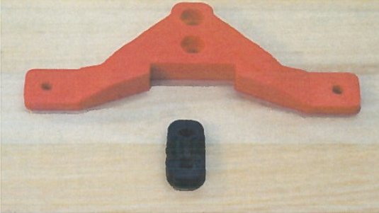

|  |  |  |
| --- | --- | --- |
| Connector Bracket |  |  |



3D Printed Parts: flexMendel

|  |  |
| --- | --- |
| Adj. Z Limit Switch and knobTiny | Foot |

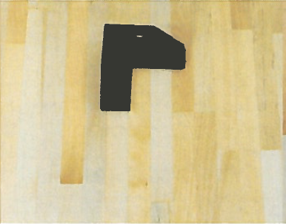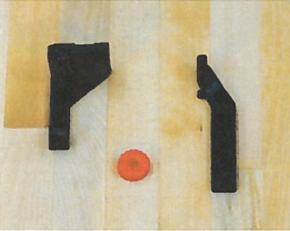

|  |  |
| --- | --- |
| Idler Washer | LCD Panel Front and Back |

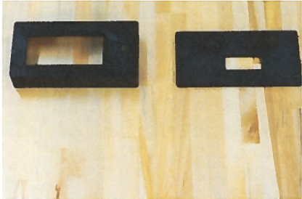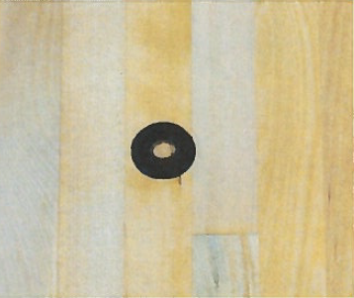

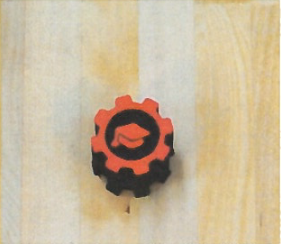

|  |  |
| --- | --- |
| Nut Cap | OSC Knob |

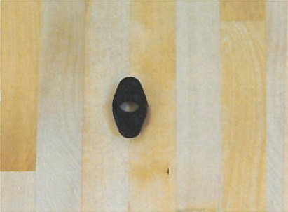

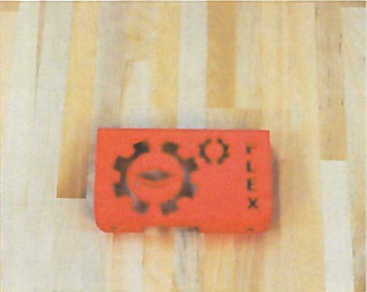

|  |  |
| --- | --- |
| RAMPs Bracket | RAMPs Cover |

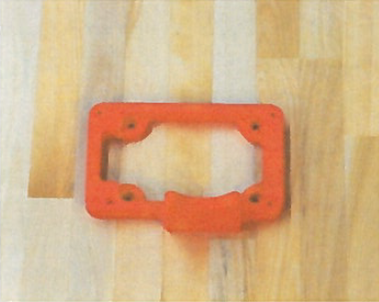

|  |  |
| --- | --- |
| Reel Holder and Filament Guide | Smooth Rod Lock |

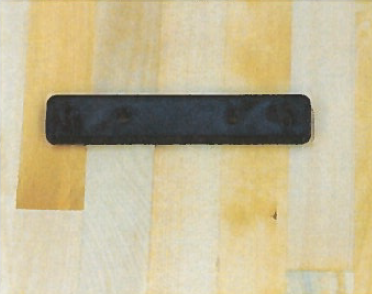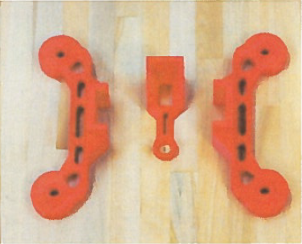

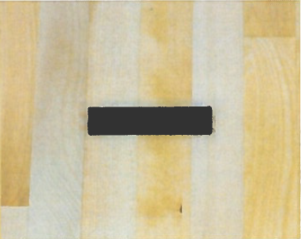

|  |  |
| --- | --- |
| Solid State Relay Bracker | T-Slot Cover |

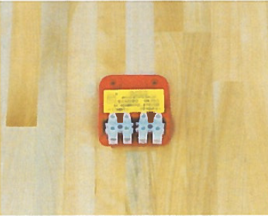

|  |  |
| --- | --- |
| xRodSupport Motor and Idler | Y belt Bracket and Y Belt Clamp |

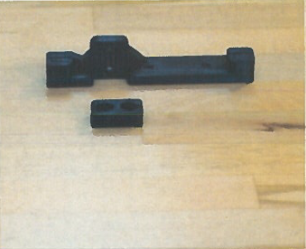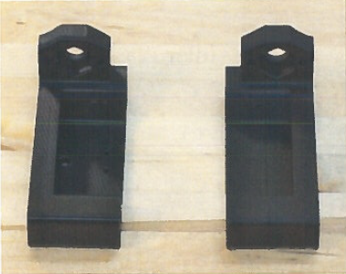

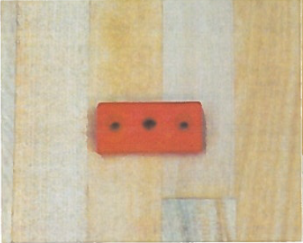

|  |  |
| --- | --- |
| Y Limit Switch Bracket | Y Slide Retainer |

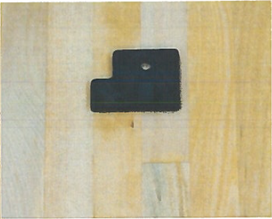

|  |  |
| --- | --- |
| Z Bearing Housing | Z Locator Bracket |

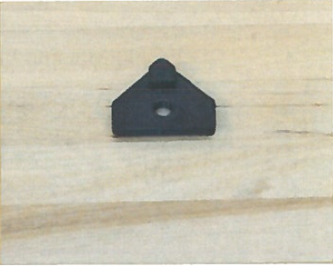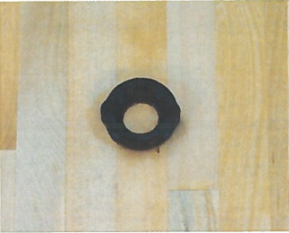

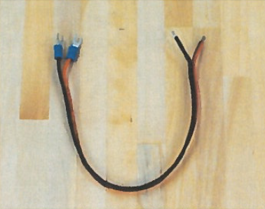Wire Kit:

|  |  |
| --- | --- |
| AC Power Switch Wire | AC SS Relay Wire |

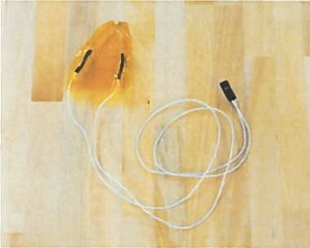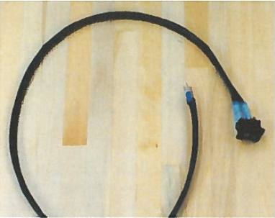

|  |  |
| --- | --- |
| Bed Grounding Wire | Bed Thermistor Wire |

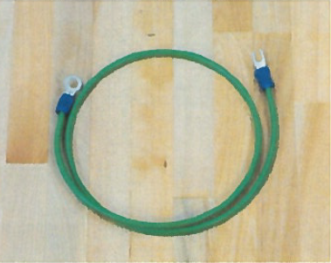

|  |  |
| --- | --- |
| 30mm Box Fan | AC SS Relay Wire |

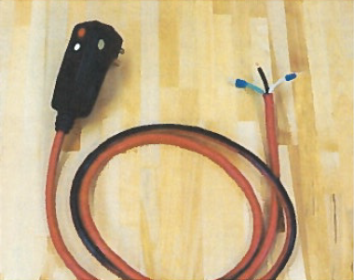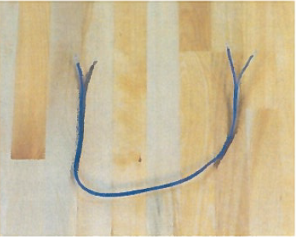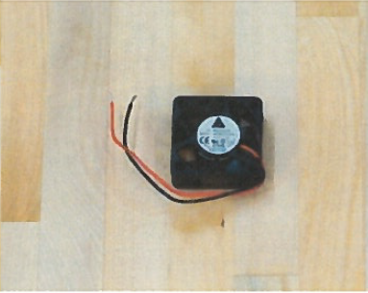

|  |  |
| --- | --- |
| AC Power Switch Wire | AC SS Relay Wire |

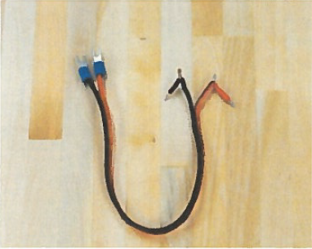

|  |  |
| --- | --- |
| Heat pad | Hot End Kit |

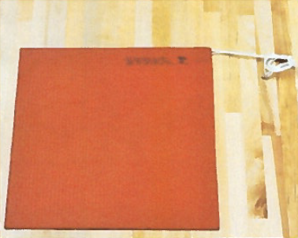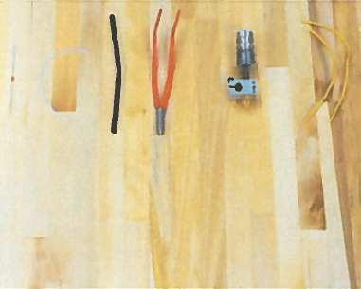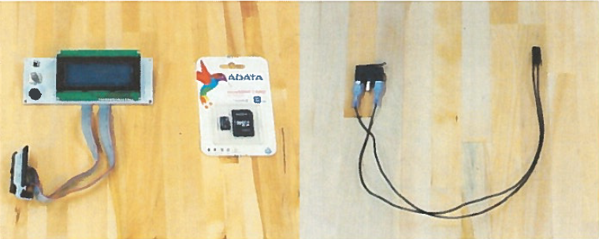

|  |  |
| --- | --- |
| LCD Smart Controler | Limit Switch |

|  |  |
| --- | --- |
| NEMA 14 Stepper Motor (Ext) | NEMA 17 Stepper Motor (X,Y,LZ,RZ) |

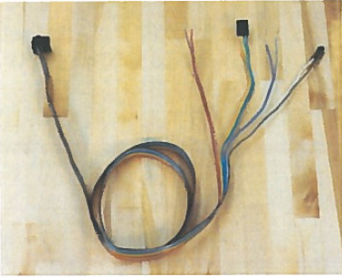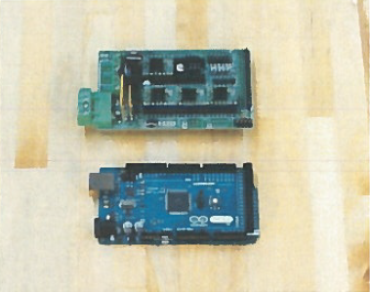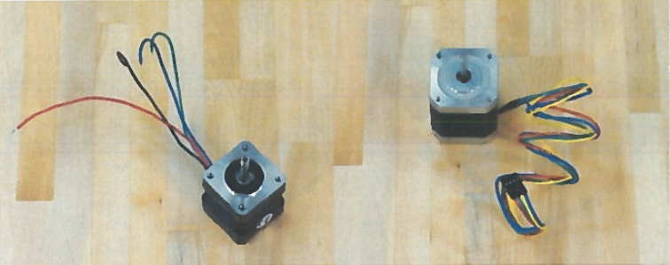

|  |  |
| --- | --- |
| RAMPs Shield/Arduino | Ribbon Cable |

|  |  |
| --- | --- |
| Wire Sheaths | Yellow Wire Nut |

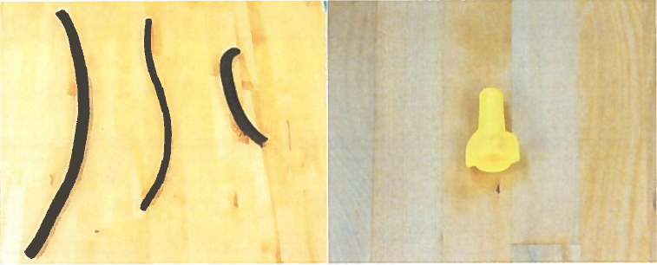

|  |  |  |
| --- | --- | --- |
| Zip Ties (small and large) |  |  |

